**BPH SEM-1**

**QUESTIONS FOR PRACTICAL EXAM PREPARATION:**

1. Define least count of an instrument.

Ans. The smallest value that can be measured by the measuring instrument is called its least count.

1. What is the least count of meter scale, vernier caliper and micrometer screw gauge?

Ans. Least count of meter scale = 0.1cm

Least count of vernier caliper=0.01cm

Least count of micrometer screw gauge=0.001cm

1. Write the formula of least count of vernier caliper.

Ans.

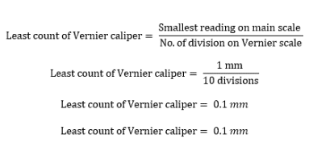

1. Write the formula of least count of micrometer screw gauge.

Ans

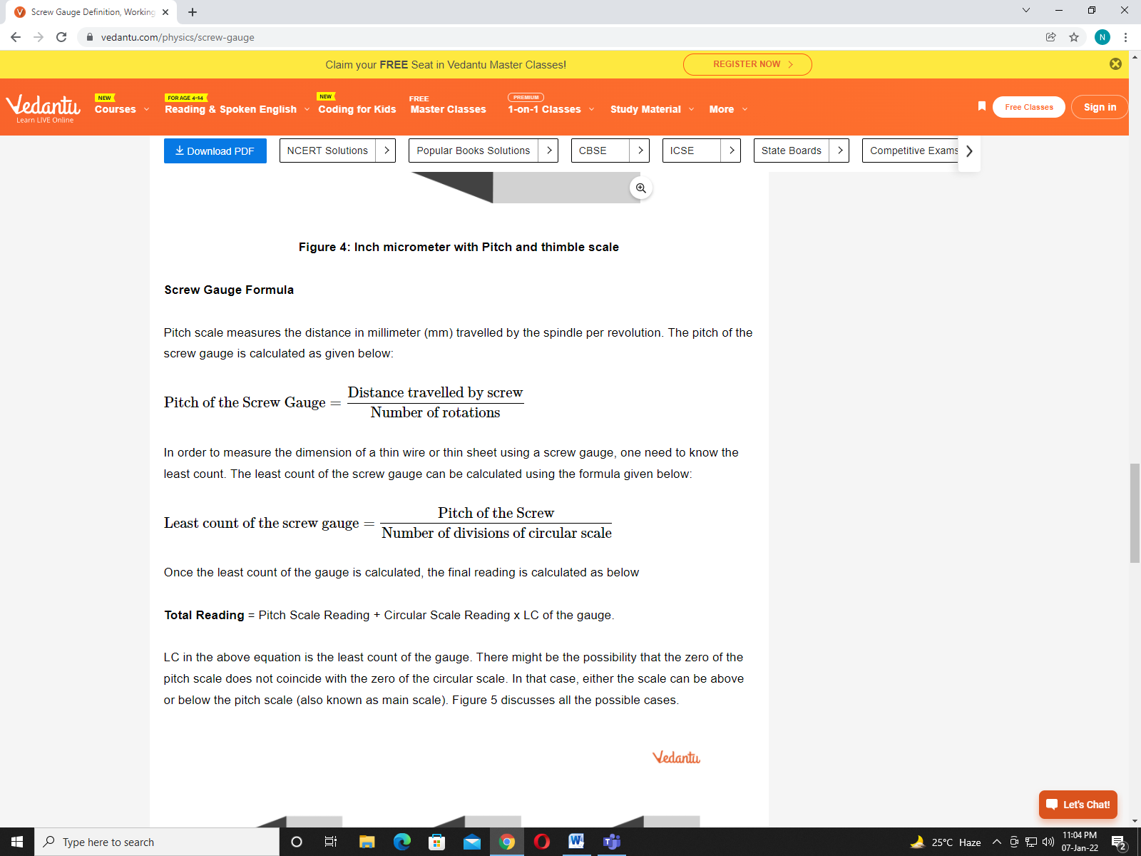

1. Define pitch.

Ans. Pitch scale measures the distance travelled by the spindle per revolution.

1. Among these (meter scale, vernier caliper and micrometer screw gauge) which instrument is the most accurate?

Ans since the least count of micrometer screw gauge is less, hence it is most accurate.

1. Define zero error and its types in vernier caliper.

## Ans. when the zeroth division on the vernier scale does not coincide with the zeroth division on the main scale, the vernier calipers has zero error. It can be either positive or negative.

1. What is the use of spherometer?

Ans A spherometer is an instrument used for the precise measurement of the [radius of curvature](https://en.wikipedia.org/wiki/Radius_of_curvature) of a [sphere](https://en.wikipedia.org/wiki/Sphere) or a curved surface.

1. Define radius of curvature of lens.

Ans. The radius of curvature is the radius of sphere formed by the convex or concave mirror. It is also equal to the distance between the pole and centre of curvature.

1. Spherometer has how many legs?

Ans. It has 3 legs.

1. Define Ohm’s law.

Ans. Ohm’s law states that the voltage across a conductor is directly proportional to the current flowing through it, provided all physical conditions and temperature remain constant.

1. Write the use of voltmeter and ammeter.

Ans. A voltmeter is an instrument used for measuring electrical potential difference between two points in an electric circuit.

An ammeter is a measuring device used to measure the electric current in a circuit.

1. Write ohm’s law equation.

Ans. V = IR, where V is the voltage across the conductor, I is the current flowing through the conductor and R is the resistance provided by the conductor to the flow of current.

1. Define resistance and what is its unit?

Ans. Resistance is the property of a conductor due to which it opposes the flow of current through it. Its S.I unit is ohm (Ω).

1. Define resistivity and write its unit.

Ans. Resistivity can be defined as the resistance of a conducting material per unit length with unit area of cross section.   
So it SI unit will be ohm-meter (Ω-m)

1. What is the another name of resistivity?

Ans. Specific resistance

1. Write the formula of resistivity.

Ans. The resistivity formula is expressed as

 Resistivity Formula

Where ρ is the resistivity, R is the resistance, l is the length of the material and A is the area of cross-section.

1. What is the reciprocal of resistivity?

Ans. Reciprocal of resistivity is conductivity.

1. Write the use of rheostat.

Ans. **rheostat**, adjustable [resistor](https://www.britannica.com/technology/resistor) used in applications that require the adjustment of [current](https://www.britannica.com/science/electric-current) or the varying of [resistance](https://www.britannica.com/technology/resistance-electronics) in an [electric circuit](https://www.britannica.com/technology/electric-circuit).

1. What is the law of resistance in series?

ans.  The equivalent resistance of a set of resistors in a series connection is equal to the algebraic sum of the individual resistances.

1. What is the law of resistance in parallel?

Ans. the reciprocal of the combined resistance of all the resistors connected in parallel is equal to the sum of the reciprocal of all the individual resistance.

1. Define depletion region.

Ans. when p and N type of semiconductors combine together, they form a junction called depletion region.

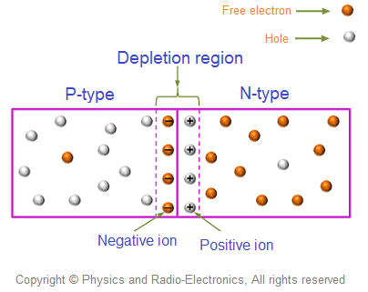

1. Define barrier potential.

## Ans. The electric field formed in the depletion region acts as a barrier.

1. How to connect diode in forward biased?

## Ans. Forward biased means that positive end of the battery is connected to the p-junction and negative end connect to the n-junction of the diode.

1. How to connect diode in reversed biased?

## Ans. reversed biased means that positive end of the battery is connected to the n-junction and negative end connect to the p-junction of the diode.

1. Ideally in which biased ,current has to flow through diode?

Ans. Forward biased

1. Define knee voltage and write its another name.

Ans. The  voltage at which the  forward-biased diode starts conducting is called knee voltage or  cut-in voltage of PN junction diode.

1. Ideal value of knee voltage for silicon and germanium diode.

Ans. For silicon= 0.7 volts

For germanium= 0.3 volts

1. Define boyle’s law and write its equation.

Ans. Boyle’s law is a gas law which states that the pressure exerted by a gas (of a given mass, kept at a constant temperature) is inversely proportional to the volume occupied by it.

1. Define Joule’s law.and write the formula of joule’s constant.

Ans. the heat produced by an electric current is equal to the product of the resistance of the conductor, the square of the current, and the time for which it flows

1. What is the ideal value of Joule’s constant?

Ans. 4186 J/Kcal

1. How to calculate Joule’s constant by graph?

Ans. Plot a graph of work against heat .slope of this graph gives the value of joule’s constant.

1. What is the procedure to calculate Joule’s constant by experiment?

Ans. Supply current through the coil which is dipped in a water inside the calorimeter. As current flowing through the coil , water inside the calorimeter starts heating. So we have to note down the temperature of water after the interval of 5mins. And using this we can calculate work and heat and at the end joule’s constant.

1. Write the formula of Joule’s constant.

Ans. J=W/H where J= joule’s constant W= work H= heat

1. In Joule’s Law experiment electrical energy is converted into which form?

Ans. Electrical energy is converted into heat energy.

1. Define refraction of light .

Ans. Refraction is the change in the direction of a wave passing from one medium to another

1. Define reflection of light .

Ans. Reflection is when light bounces off an object.

1. What is the angle of prism and its value ?

The angle formed due to two lateral faces of the prism is known as the angle of prism.

Its value is 60 degree.

1. Define snell’s law

Ans. *The ratio of the sine of the angle of incidence to the sine of the angle of refraction is a constant,and that constant is called as refractine index.*

1. Define minimum deviation.

Ans. Angle of minimum deviation is the minimum angle at which the angle of incidence will be equal to the angle of emergence and the refracted ray will be parallel to the base of the prism.

1. Define refractive index of prism and its formula.

Ans. Refractive index is defined as The ratio of the speed of light in a vacuum to its speed in a specific medium.

n=c/v where n= refractive index c= speed of light in air v= speed of light in medium

1. What is the Standard value of refractive index of air?

Ans . 1

1. What is the Standard value of refractive index of glass material?

ans. 1.5

1. What is total internal reflection?

Ans. complete [reflection](https://www.britannica.com/science/reflection-physics) of a ray of [light](https://www.britannica.com/science/light) within a medium such as water or glass from the surrounding surfaces back into the medium.

1. Define critical angle.

Ans. The critical angle is defined as the angle of incidence which provides a 90-degree angle of refraction.

1. What is the formula of refractive index in terms of critical angle?

Ans. n=1/sin ic where n= refractive index ic= critical angle

1. What are the two conditions of total internal reflection?

Ans. 1. Light has to travel from denser to rarer medium.

2. Angle of incidence should greater than critical angle.

1. Application of total internal reflection.

Ans. Optical fiber